**Software Project Design Plan**

Voice Controlled Drone

Aldwin Akbar Hermanudin

Rudy Nurhadi

Tomi

**Software Project Design Plan**

**for**

***Voice Controlled Drone***

***Aldwin Akbar, Rudy Nurhadi, Tomi***

***October 5th 2015***

|  |  |  |  |
| --- | --- | --- | --- |
| **Version** | **Release Date** | **Responsible Party** | **Major Changes** |
| 0.1 | October 5th 2015 | Team Leader | First Draft |
|  |  |  |  |
|  |  |  |  |
|  |  |  |  |
|  |  |  |  |
|  |  |  |  |

**DESIGN**

Designing is the process in which the team creates a specification of a software artifact, intended to accomplish goals, using a set of primitive components and regarding the constraints. Designing is the step of conceptualizing, planning, and understanding the foundation and process of the projects.

* **UML Diagram**

UML, which stands for Unified Modeling Language, is really important as the pre-process state. This object-oriented system of notation has been evolved from the works of Grady Booch, James Rumbaugh, Ivar Jacobson, and the Rational Software Corporation. These renowned computer scientists fused their respective technologies into a single, standardized model. Today, UML is accepted by the Object Management Group (OMG) as the standard for modeling object oriented programs. UML defines many kind types of diagrams: class (package), use case, sequence, activity, and deployment.

1. **Use Case Diagram**

This diagram shows the user and what “Voice Controlled Drone” system provides for them. In this case, the application lets users sent data from voice to command the drone.

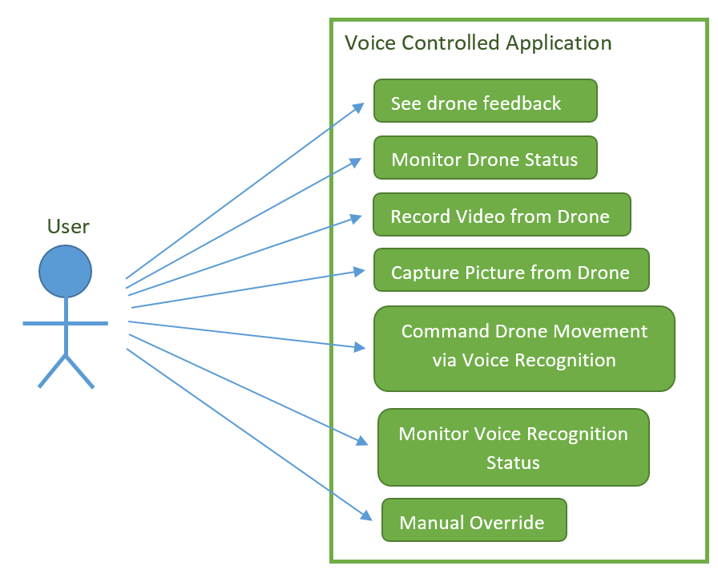

Figure 1. Use Case Diagram

1. **Sequence Diagram**

Sequence diagram below explains how the operation is performed by the application. Here is how the operation works.

Users will sent a data from his/her phone after user give commands using voice to drone via “Voice Controlled Drone”, the software will translate it to string and sent it to drone. Then drone will receive the data via Internet and do what the user request. The feedback from drone is request command the drone gets from user.

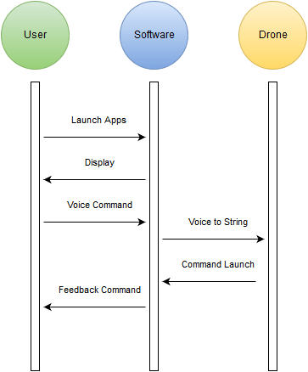

Figure 2. Sequence Diagram

1. **Deployment Diagram**

Deployment diagram illustrates the physical architecture of the system in terms of the hardware deployed on and the communication links between hardware nodes. By connecting via Internet, it is possible to deliver data from phone to drone.

C:\Users\HP\AppData\Local\Microsoft\Windows\INetCache\Content.Word\Untitled Diagram(1).png

Figure 3. Deployment Diagram

1. **Activity Diagram**

This diagram describes the flow of activities or tasks. It resembles a flow chart. It has decision points and synchronisation bars. The synchronisation bars show activities that can happen in either order or even at the same time. “Voice Control Drone” activity diagram below explains the step-by-step activities provide by “Voice Control Drone”. First of all, the software will accept input from the user which is user voice command, and then the system will determine the voice command and translate it to a string. Secondly, the software will sent a data via internet to the drone. If the drone do not give feedback for 5 seconds, the command failed. Otherwise if the command is received by the drone, the drone will sent feedback which is displaying command information that user has given in the beginning.

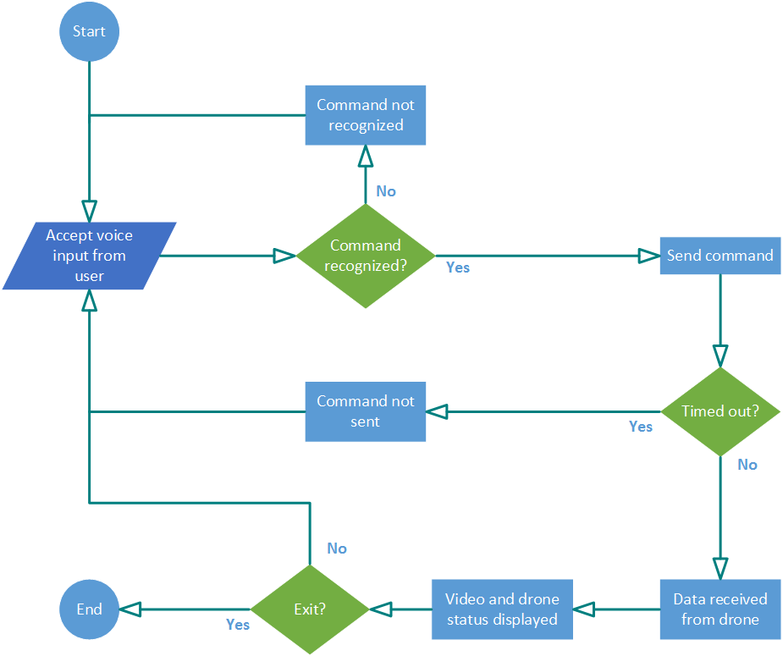

Figure 4. Activity Diagram

1. **Class Diagram**

This diagram explains the class of the program and describes the interconnection between the classes.

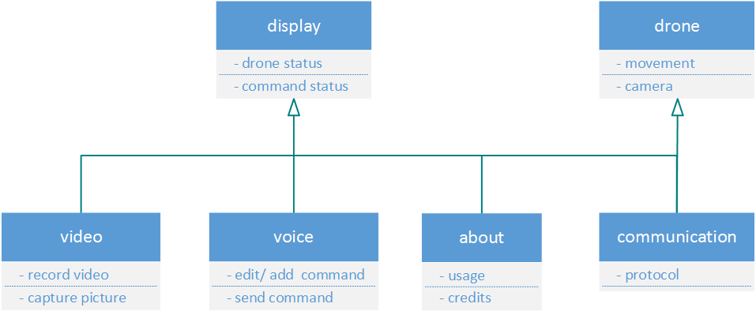

Figure 5. Class Diagram